**UNIT - 1**

**Soft Computing**

Soft computing is an **advanced computational approach** that differs from traditional (hard) computing by using **approximate models and adaptive techniques** to solve complex real-world problems.

It is based on **artificial intelligence, machine learning and evolutionary computation**, making it suitable for handling uncertainty, vagueness and imprecision in data.

**Unlike conventional computing**, which relies on **strict rules and precise algorithms**, it provides **flexible and cost-effective solutions** to the complex real-life problems for which hard computing solution **does not exist**.

**Components of Soft Computing**

1. **Fuzzy Logic (FL)**
   * Based on **degrees of truth** instead of traditional **binary true/false logic**, allowing for **gradual decision-making** rather than absolute outcomes.
   * Helps in applications like **control systems (air conditioners, washing machines), expert systems and medical diagnosis**, where decisions need to be made in **uncertain environments**.
2. **Machine Learning (ML)**
   * Focuses on **enabling computers to learn from data** without being explicitly programmed, improving **efficiency and accuracy** over time.
   * Used in applications such as **speech recognition (Alexa, Siri), fraud detection, recommendation systems (Netflix, Amazon), and financial forecasting**.
3. **Neural Networks (NN)**
   * Inspired by the **human brain**, neural networks consist of interconnected nodes (neurons) that process and recognize **patterns and relationships** in data.
   * Applied in **image recognition (facial recognition), medical diagnostics (cancer detection), and autonomous systems (self-driving cars, robotics)**.
4. **Probabilistic Reasoning**
   * Involves **statistical techniques and probability theory** to make decisions under **uncertainty and incomplete information**.
   * Used in **spam detection (email filters), weather prediction, and risk assessment in financial markets**.
5. **Evolutionary Computation (EC)**
   * Uses concepts like **natural selection, mutation, and genetic evolution** to **optimize and improve problem-solving strategies**.
   * Applied in **genetic algorithms (GAs), swarm intelligence, game AI, and complex engineering design optimization**.

**Advantages of Soft Computing**

1. **Robustness in Handling Uncertainty**
   * Soft computing techniques can handle **imprecise, noisy, and uncertain data** that traditional computing methods cannot process effectively.
   * This makes it suitable for **real-world applications such as stock market prediction, robotics, and automated control systems**.
2. **Provides Approximate Solutions for Complex Problems**
   * Many real-world problems **do not have exact solutions**; soft computing provides **workable approximations** that are **sufficiently accurate**.
   * Used in applications like **natural language processing (Google Translate), autonomous vehicles, and decision-support systems**.
3. **Effective for Non-linear and Dynamic Problems**
   * Unlike hard computing, which struggles with **complex and dynamic systems**, soft computing can **adapt to changing environments**.
   * Beneficial in fields like **climate modeling, economic forecasting, and industrial automation**.
4. **Mimics Human-like Reasoning for Better Decision Making**
   * Soft computing algorithms are designed to **imitate human problem-solving skills**, making them **intuitive and efficient**.
   * This is especially useful in **medical diagnosis, intelligent tutoring systems, and smart home automation**.
5. **Real-time Problem Solving Capabilities**
   * Soft computing techniques can process **data quickly and provide solutions in real time**, making them ideal for **real-time applications**.
   * Used in **traffic control systems, fraud detection in banking, and cybersecurity threat analysis**.

**Needs/Requirements of Soft Computing**

1. **Real-world Problems are Highly Complex**
   * Many real-world problems involve **uncertainty, vagueness, and imprecision**, making traditional computing ineffective.
   * Soft computing techniques help in **areas like speech recognition, natural language understanding, and weather forecasting**.
2. **Incomplete and Inconsistent Information**
   * In many cases, there is **not enough data** to make an exact decision, and soft computing helps by providing **approximate solutions**.
   * Examples include **medical diagnosis (predicting disease progression), customer behavior analysis, and autonomous decision-making in AI**.
3. **Dealing with Noisy and Uncertain Data**
   * Real-world data is often **incomplete, noisy, or inconsistent**, making it difficult to process using conventional techniques.
   * Soft computing techniques excel in **fields like cybersecurity (intrusion detection systems) and sensor data analysis (self-driving cars)**.
4. **Non-linearity in Problem Solving**
   * Many problems are **non-linear in nature**, meaning they do not follow a straightforward mathematical model.
   * Soft computing techniques such as **fuzzy logic and neural networks** can **model and solve such problems** in **finance, medicine, and robotics**.
5. **Human-like Intelligence for Better Automation**
   * Traditional computing lacks **adaptability and learning capabilities**, whereas soft computing can **adjust and improve with experience**.
   * This is crucial in **AI-driven systems like self-learning chatbots, automated customer support, and smart recommendation systems**.

**Applications of Soft Computing**

1. **Gaming Industry**
   * Soft computing techniques help create **intelligent opponents in video games**, allowing for more **realistic and adaptive gameplay**.
   * Used in games like **Poker, Chess, and AI-based strategy games**.
2. **Smart Home & Kitchen Appliances**
   * Fuzzy logic and neural networks are used in **appliances like washing machines, microwave ovens, and air conditioners** to **optimize performance**.
   * These devices can **adjust their behavior based on user preferences and environmental conditions**.
3. **Robotics & Artificial Intelligence**
   * Robots with **soft computing capabilities** can adapt and learn from their environment, improving their interactions with humans.
   * Used in **emotional robots, warehouse automation, and robotic healthcare assistants**.
4. **Handwriting Recognition & Image Processing**
   * Soft computing is used to **recognize handwriting and convert images into text**, improving **OCR (Optical Character Recognition) systems**.
   * Applied in **postal services, banking (cheque verification), and document digitization**.
5. **Healthcare and Medical Diagnosis** 
   * **Soft computing techniques, such as neural networks and fuzzy logic, assist in disease diagnosis, medical image analysis, and treatment planning.**
   * **Used in cancer detection, personalized medicine, and AI-assisted medical decision-making to improve patient care and accuracy.**

**Importance of Soft Computing**

1. **Bridges the Gap Between Human Intelligence & Machines**
   * Soft computing techniques enable machines to **reason, learn, and adapt** like humans, improving **decision-making capabilities**.
   * This has led to advancements in **personalized AI assistants (Siri, Google Assistant) and self-learning algorithms**.
2. **Handles Uncertainty and Approximation**
   * Unlike traditional computing, which requires **precise inputs**, soft computing can process **vague, imprecise, and uncertain data** effectively.
   * This is useful in **medical diagnosis (predicting disease risk), autonomous driving (handling uncertain road conditions), and financial forecasting**.
3. **Improves AI and Machine Learning Capabilities**
   * Soft computing techniques, such as **neural networks and fuzzy logic**, help AI systems **learn from experience and make better decisions**.
   * Applied in **chatbots (Siri, Alexa), recommendation systems (Netflix, Amazon), and self-driving cars (Tesla Autopilot)**.
4. **Essential for Big Data and Analytics**
   * Soft computing enables efficient **data analysis and pattern recognition** in large and complex datasets.
   * Crucial in **fraud detection (banking systems), personalized marketing (Google Ads, Facebook Ads), and climate modeling**.
5. **Enables Cost-effective and Scalable Solutions**
   * Soft computing **reduces computational complexity** by providing **approximate but useful solutions**, saving time and resources.
   * Used in **traffic management systems, smart grids (energy optimization), and healthcare decision-support systems**.

**Hard Computing** vs **Soft Computing**

| **BASIS** | **HARD COMPUTING** | **SOFT COMPUTING** |
| --- | --- | --- |
| **Tolerance** | Requires a **strictly stated analytic model**. | Liberal of **inexactness**, **uncertainty**, **partial** **truth**, and **approximation**. |
| **Logic** | **Relies on binary logic and crisp systems**. | **Relies on formal logic and probabilistic reasoning**. |
| **Characteristics** | Focuses on **precision and exact solutions**. | Emphasizes **approximation and flexibility**. |
| **Nature** | **Deterministic** in nature, producing fixed outcomes. | **Stochastic** in nature, incorporating randomness. |
| **Data Type** | Works on **exact data**. | Works on **ambiguous and noisy data**. |
| **Computational Approach** | Performs **sequential computations**. | Can perform **parallel computations**. |
| **Result** | Produces **precise** results. | Produces **approximate** results. |
| **Programming** | **Requires explicitly written programs**. | Can **emerge its own programs through adaptation**. |
| **Randomness** | Operates with **settled and fixed processes**. | Incorporates **randomness** in problem-solving. |
| **Logic Type** | Uses **two-valued logic** (true/false). | Uses **multivalued logic** for degrees of truth. |

**UNIT - 2**

**Neural Networks**

Neural networks are machine learning models that mimic the complex functions of the human brain. These models consist of interconnected nodes or neurons that process data, learn patterns, and enable tasks such as pattern recognition and decision-making. Neural networks are capable of learning and identifying patterns directly from data without pre-defined rules.

**Key Characteristics of Neural Networks:**

1. **Parallel Processing: Multiple neurons process data simultaneously, improving efficiency.**
2. **Adaptability & Learning: Neural networks learn from data using weights and biases.**
3. **Generalization Ability: Once trained, NNs can apply learned knowledge to unseen data.**
4. **Fault Tolerance: A neural network can still function even if some neurons fail.**

**Layers in Neural Network Architecture**

1. **Input Layer:**This is where the network receives its input data. Each input neuron in the layer corresponds to a feature in the input data.
2. **Hidden Layers:**These layers perform most of the computational heavy lifting. A neural network can have one or multiple hidden layers. Each layer consists of units (neurons) that transform the inputs into something that the output layer can use.
3. **Output Layer:**The final layer produces the output of the model. The format of these outputs varies depending on the specific task (e.g. classification, regression).

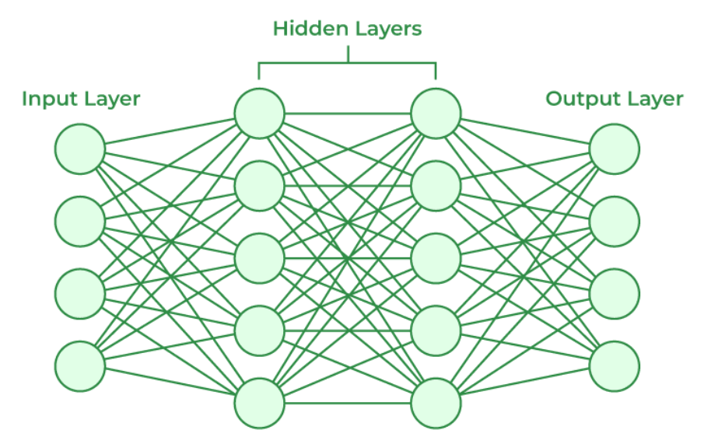

**Working of Neural Networks**

1. **Forward Propagation**

When data is input into the network, it passes through the network in the forward direction, from the input layer through the hidden layers to the output layer. This process is known as forward propagation. Here’s what happens during this phase:

1. **Linear Transformation:** Each neuron in a layer receives inputs, which are multiplied by the weights associated with the connections. These products are summed together, and a bias is added to the sum. This can be represented mathematically as: *z* = *w*1​*x*1 ​+ *w*2​*x*2​ + ….. + *wn*​*xn* ​+ *b*  where *w* represents the weights, *x* represents the inputs, and *b* is the bias.
2. **Activation:** The result of the linear transformation (denoted as z*z*) is then passed through an activation function. The activation function is crucial because it introduces non-linearity into the system, enabling the network to learn more complex patterns. Popular activation functions include ReLU, sigmoid, and tanh.
3. **Backward Propagation**

After forward propagation, the network evaluates its performance using a loss function, which measures the difference between the actual output and the predicted output. The goal of training is to minimize this loss. This is where backpropagation comes into play:

1. **Loss Calculation:** The network calculates the loss, which provides a measure of error in the predictions. The loss function could vary; common choices are mean squared error for regression tasks or cross-entropy loss for classification.
2. **Gradient Calculation:** The network computes the gradients of the loss function with respect to each weight and bias in the network. This involves applying the chain rule of calculus to find out how much each part of the output error can be attributed to each weight and bias.
3. **Weight Update:** Once the gradients are calculated, the weights and biases are updated using an optimization algorithm like stochastic gradient descent (SGD). The weights are adjusted in the opposite direction of the gradient to minimize the loss. The size of the step taken in each update is determined by the learning rate.

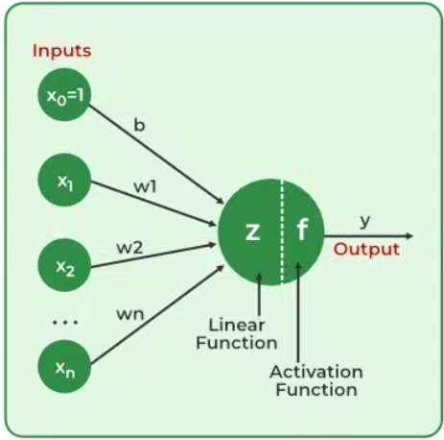

**Applications of Neural Networks**

1. **Image and Speech Recognition**

* Used in **face recognition (Facebook, iPhones), voice assistants (Siri, Alexa), and security surveillance systems**.
* Neural networks analyze pixel patterns and speech frequencies for accurate identification.

1. **Healthcare & Medical Diagnosis**

* Helps in **disease detection (cancer, COVID-19), drug discovery, and personalized treatment plans**.
* ANN models analyze large patient datasets for improved diagnostics and treatment recommendations.

1. **Financial Predictions & Stock Market Analysis**

* Neural networks assist in **predicting stock trends, fraud detection, and credit risk assessment**.
* Banks use them for **loan approvals and identifying suspicious transactions**.

1. **Robotics & Automation**

* ANN-powered robots learn **movement patterns, object recognition, and human interaction**.
* Used in **self-driving cars (Tesla, Waymo), robotic surgeries, and industrial automation**.

1. **Natural Language Processing (NLP)**

* Neural networks enable **chatbots, translation apps, and text prediction (Google Translate, Grammarly, ChatGPT)**.
* Improves human-computer interaction by understanding and processing languages.

**UNIT - 3**

**Fuzzy Logic**

**Fuzzy Logic** is a **mathematical approach** used to deal with **uncertainty** and **imprecision**, **allowing for partial truths instead of just true or false**. It is based on the idea that many real-world situations are not black and white, and there are degrees of truth in between. In Fuzzy Logic, truth values can **range from 0 to 1**, with **0** **indicating non-membership** and **1 indicating full membership**. It is used in various applications like **control systems**, **image processing**, **natural language processing** and **AI**.

The **core concept** of Fuzzy Logic is the **membership function**, which assigns a degree of membership to input values. It operates using **Fuzzy Rules** (if-then statements) that express relationships between inputs and outputs in a fuzzy manner. The output of a fuzzy system is a fuzzy set with membership degrees for each possible value.

**Fuzzy Logic Architecture** consists of four components:

1. **Rule Base**: A set of expert-provided rules for decision-making.
2. **Fuzzification**: Converts crisp inputs (e.g. temperature, pressure) into fuzzy sets.
3. **Inference Engine**: Matches input values to rules and decides which rules to activate.
4. **Defuzzification**: Converts fuzzy outputs back into crisp values, with various methods to reduce errors.

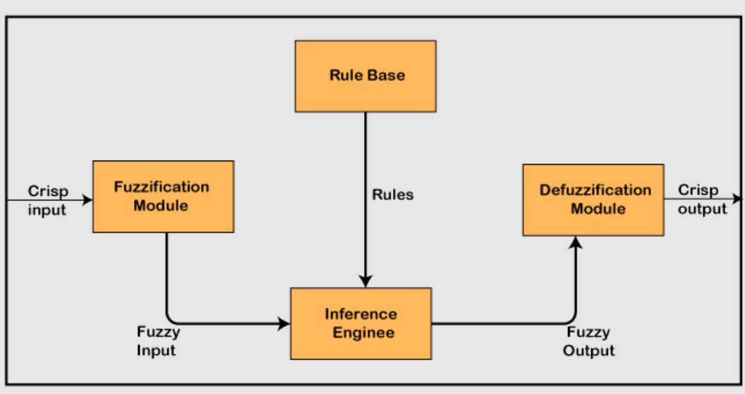

| **BASIS** | **FUZZY SET** | **CRISP SET** |
| --- | --- | --- |
| **Definition** | Defines the **value between 0 and 1, including both**. | Defines the **value as either 0 or 1**. |
| **Alternative Name** | Known as a **fuzzy or approximate set**. | Also called a **classical set**. |
| **Membership** | Shows **partial membership**, with degrees of truth. | Shows **full membership** (either true or false). |
| **Degree of Membership** | **Membership is continuous, ranging from 0 to 1**. | **Membership is binary, either 0 or 1**. |
| **Application** | Used in **fuzzy controllers** to manage **imprecision**. | Used in **digital design** where **precision is key**. |
| **Logic Type** | **Infinite-valued logic** (continuous range of values). | **Bi-valued logic** (true/false, 0/1). |
| **Membership Nature** | **Partial membership** means true to false, yes to no, 0 to 1. | **Full membership** means totally true/false, yes/no, 0/1. |
| **Complexity** | **More complex**, useful for handling uncertainty and approximation. | **Simpler**, used for well-defined, crisp problems. |
| **Example 1** | She is **about** 18 years old. | She is **exactly** 18 years old. |
| **Example 2** | Rahul is **about** 1.6m tall. | Rahul is **exactly** 1.6m tall. |

**Fuzzy Set Theory and Its Applications**

Fuzzy Set Theory is an advanced approach to handling uncertainty and imprecision in real-world scenarios. Unlike classical Boolean logic, where an element either belongs to a set (1) or does not belong to it (0), fuzzy set theory introduces the concept of **partial membership**, allowing for more realistic decision-making in uncertain environments.

Fuzzy Set Theory was introduced by **Lotfi Zadeh in 1965** to address the limitations of binary logic when dealing with vague, ambiguous, or imprecise data.

**Key Characteristics of Fuzzy Sets:**

1. **Partial Membership:** Instead of a strict yes/no classification, elements belong to a set with a certain **degree of membership** ranging from **0 to 1**.
2. **Membership Function (μ):** Defines the degree to which an element belongs to a set, representing a **continuous range of possibilities**.
3. **Linguistic Variables:** Instead of numerical values, fuzzy sets allow the use of terms like **"low," "medium," and "high"**, improving human-like decision-making.
4. **Fuzzy Set Operations:** Unlike classical sets, fuzzy sets perform operations like **union, intersection, and complement** using degrees of membership rather than absolute values.

**Example of a Fuzzy Set (Temperature Classification):**

* **Cold (0.0 - 0.5), Warm (0.3 - 0.8), Hot (0.6 - 1.0).**
* A temperature of **25°C** may have **0.7 membership in "Warm"** and **0.2 in "Cold"**, instead of being strictly classified as one or the other.

**Applications of Fuzzy Set Theory:**

* **Artificial Intelligence (AI):** Improves decision-making in **robotics and natural language processing (NLP)**.
* **Medical Diagnosis:** Helps in classifying diseases based on **symptoms with uncertainty**.
* **Control Systems:** Used in **air conditioners, washing machines, and traffic lights**.

**Fuzzy Rule-Based Systems (FRBS)**

A **Fuzzy Rule-Based System (FRBS)** is an inference system that applies **fuzzy logic to decision-making** by using a set of predefined **IF-THEN rules**. It allows systems to handle vague and imprecise information more efficiently than traditional rule-based approaches.

**Key Components of FRBS:**

1. **Fuzzy Rules:** These define how input variables influence output decisions.

Example: *IF temperature is high THEN fan speed is fast.*

1. **Fuzzy Inference System (FIS):** Converts crisp inputs into fuzzy values, processes them using rules, and produces fuzzy outputs.
2. **Defuzzification:** Converts the fuzzy result into a **crisp value** for real-world application.

**Example: Smart Air Conditioning System**

* **IF the room temperature is high THEN increase the cooling speed.**
* **IF the outside humidity is high THEN reduce the cooling speed.**

**Applications of FRBS:**

* **Home Automation:** Used in **smart thermostats, refrigerators, and lighting systems**.
* **Medical Systems:** Used in **diagnosis support for diseases like diabetes**.
* **Industrial Control:** Applied in **chemical processing plants and robotics**.

**Predicate Logic in Fuzzy Systems**

**Predicate Logic** extends classical logic by introducing variables, allowing more **flexibility in decision-making**. In fuzzy logic, predicates enable reasoning with **vague and uncertain data**.

**Key Features of Predicate Logic in Fuzzy Systems:**

1. **Predicates:** Statements that express relationships between objects.

Example: "X is tall" (where **X is a variable**, and "tall" is fuzzy).

1. **Quantifiers:** Express uncertainty, such as **"most," "some," or "few."**
2. **Fuzzy Operators:** Logical operators **(AND, OR, NOT)** are used with degrees of truth rather than absolute true/false values.

**Example in Medical Diagnosis:**

* **IF (blood pressure is HIGH) AND (heart rate is HIGH) THEN (risk of heart attack is HIGH).**

**Applications of Predicate Logic in Fuzzy Systems:**

* **AI-based Chatbots:** Used in **natural language understanding (NLU)**.
* **Medical Decision Support Systems:** Helps in **predicting disease probabilities**.

**Fuzzy Decision Making**

Fuzzy Decision Making (FDM) is used in situations where data is **imprecise, uncertain, or subjective**, making traditional decision-making difficult.

**Key Steps in Fuzzy Decision Making:**

1. **Identify Decision Variables:** Define the factors affecting the decision.
2. **Define Membership Functions:** Assign degrees of belonging to different classes.
3. **Apply Fuzzy Rules:** Use IF-THEN logic to evaluate different outcomes.
4. **Fuzzy Inference:** Compute the fuzzy output based on input conditions.
5. **Defuzzification:** Convert the fuzzy result into a crisp decision.

**Example: Investment Decision in Stock Market**

* **IF market risk is HIGH AND return potential is LOW, THEN do not invest.**
* **IF market risk is LOW AND return potential is HIGH, THEN invest.**

**Applications of Fuzzy Decision Making:**

✔ **Finance & Banking:** Used for **credit risk assessment and stock trading**.  
✔ **Healthcare:** Applied in **patient treatment selection**.

**Fuzzy Control Systems (FCS)**

Fuzzy Control Systems (FCS) use **fuzzy logic to control real-world processes** by making intelligent decisions based on approximate reasoning.

**Key Components of a Fuzzy Control System:**

1. **Fuzzification:** Converts real-world inputs into fuzzy values.
2. **Fuzzy Rule Evaluation:** Uses predefined rules to process the fuzzy values.
3. **Defuzzification:** Converts fuzzy outputs into precise control actions.

**Example: Fuzzy-based Automatic Braking System in Cars**

* **IF the distance to an obstacle is small AND speed is high, THEN apply brakes strongly.**

**Applications of Fuzzy Control Systems:**

* **Automobile Industry:** Used in **anti-lock braking systems (ABS) and cruise control**.
* **Industrial Automation:** Applied in **temperature, pressure, and speed control**.

**Fuzzy Classification**

Fuzzy Classification assigns degrees of membership to multiple categories, making it useful when **data does not fit neatly into predefined classes**.

**Key Features of Fuzzy Classification:**

1. **Overlapping Categories:** An object can belong to multiple classes with different probabilities.
2. **Fuzzy Membership Functions:** Assigns a probability of belonging to different classes.

Example**: Medical Diagnosis Classification:**

A patient’s symptoms may be **50% flu, 30% cold, and 20% allergy**, rather than a rigid classification.

**Applications of Fuzzy Classification:**

* **Pattern Recognition:** Used in **fingerprint and facial recognition**.
* **Data Mining:** Helps in **clustering and categorization of data**.

**Fuzzy Membership Functions**

A **Fuzzy Membership Function (MF)** defines how much an element belongs to a fuzzy set, assigning values **between 0 and 1**.

**Common Types of Membership Functions:**

1. **Triangular MF:** Simple and widely used, represented by a triangle.
2. **Trapezoidal MF:** Similar to triangular but with a **flat top**.
3. **Gaussian MF:** Bell-shaped curve, commonly used in **image processing**.
4. **Sigmoid MF:** S-shaped, used in **machine learning applications**.

**Example: Weather Classification**

Cold (0-0.5), Moderate (0.3-0.7), Hot (0.6-1.0).

**Applications:**

* **Image Processing:** Used for **edge detection and image enhancement**.
* **Medical Diagnosis:** Helps in **classifying diseases based on patient symptoms**.

**Operations on Fuzzy Sets**

Fuzzy set operations extend classical set operations (union, intersection, and complement) but involve **degrees of membership** rather than absolute values.

**1. Fuzzy Union (OR Operation)**

* The union of two fuzzy sets A and B is defined as: **μA∪B​(x)=max(μA​(x),μB​(x))**
* **Example:**
  + If **A** (Tall People) = {0.3, 0.6, 0.9}
  + If **B** (Athletic People) = {0.2, 0.8, 0.7}
  + **A ∪ B** = {**max(0.3,0.2), max(0.6,0.8), max(0.9,0.7)**} = {0.3, 0.8, 0.9}

**2. Fuzzy Intersection (AND Operation)**

* The intersection of two fuzzy sets is given by: **μA∩B​(x)=min(μA​(x),μB​(x))**
* **Example:**
  + Using the same values for **A** and **B**:
  + **A ∩ B** = {**min(0.3,0.2), min(0.6,0.8), min(0.9,0.7)**} = {0.2, 0.6, 0.7}

1. **Fuzzy Complement (NOT Operation)**

* The complement (negation) of a fuzzy set is given by: **μĀ​(x)=1−μA​(x)**
* **Example:**
  + **A** = {0.3, 0.6, 0.9}
  + **¬A** = {**1-0.3, 1-0.6, 1-0.9**} = {0.7, 0.4, 0.1}

**Fuzzy Relations**

Fuzzy relations extend classical relations by **assigning a degree of association** between elements rather than a strict binary relationship.

**Fuzzy Cartesian Product**

* Given two fuzzy sets **A** and **B**, their Cartesian product defines the **relationship between all pairs of elements** from each set.
* **Formula:** **R(A,B)=μA​(x)×μB​(y)**
* **Example:**
  + **A (Skill Level)** = {0.4, 0.7, 0.9}
  + **B (Experience)** = {0.5, 0.6}
  + 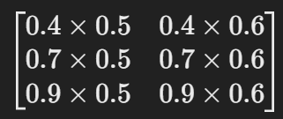**A × B** = ​

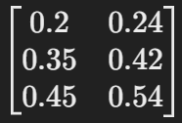

* + Result =

**Fuzzy Propositions**

Fuzzy propositions are **statements that involve imprecise or fuzzy terms** rather than precise values.

**Example:**

* **Crisp Proposition:** "The temperature is **30°C**."
* **Fuzzy Proposition:** "The temperature is **warm**." (where **warm** is a fuzzy value with a membership function).

**Types of Fuzzy Propositions:**

1. **Simple Propositions** – "The car is fast."
2. **Compound Propositions** – "The car is fast AND the road is slippery."

Fuzzy propositions help in **linguistic decision-making**, such as AI chatbots, medical diagnosis, and control systems.

**Fuzzy Implications**

Fuzzy implications are **IF-THEN rules** used in fuzzy logic systems for decision-making.

**General Form:**

* **IF (Condition) THEN (Result)**
* Example: **IF temperature is HIGH, THEN fan speed is FAST.**

**Different Types of Fuzzy Implication Operators:**

1. **Mamdani Implication** (min method): **μA→B​(x,y)=min(μA​(x),μB​(y))**
2. **Larsen Implication** (product method): **μA→B​(x,y)=μA​(x)×μB​(y)**

Fuzzy implications are used in **expert systems, decision support systems, and AI-based controllers**.

**Fuzzy Inference**

Fuzzy inference refers to **the process of deriving logical conclusions** from fuzzy premises.

**Fuzzy Inference Steps:**

1. **Fuzzification:** Convert crisp input into a fuzzy value.
2. **Rule Evaluation:** Apply fuzzy logic rules.
3. **Aggregation:** Combine results from multiple rules.
4. **Defuzzification:** Convert the fuzzy output into a crisp value.

**Example: Automated Temperature Control System**

* **Rule 1:** IF temperature is HIGH, THEN fan speed is FAST.
* **Rule 2:** IF temperature is MEDIUM, THEN fan speed is MEDIUM.
* **Rule 3:** IF temperature is LOW, THEN fan speed is SLOW.

**Application Areas:**

* AI & Machine Learning
* Industrial Automation
* Decision Support Systems

**Min-Max Composition**

Min-max composition is used in **fuzzy relational reasoning**. It determines the **strength of relationships** between elements of different fuzzy sets.

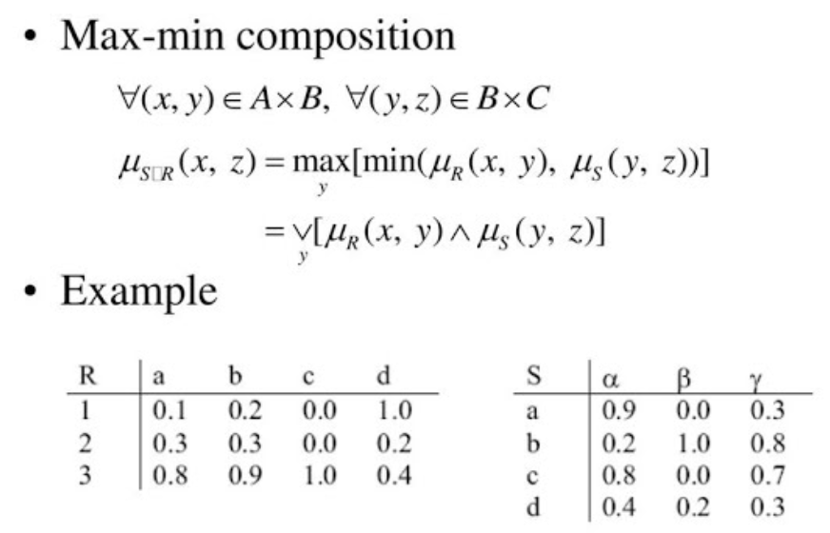

**Fuzzification**

Fuzzification is the process of **converting crisp values into fuzzy values**.

**Techniques for Fuzzification:**

1. **Linguistic Fuzzification:** Converts precise values into linguistic terms (e.g., "Speed = 70 km/h" → "Fast").
2. **Membership Function Mapping:** Assigns degrees of membership to numerical data.

**Example:**

* Crisp Input: **Weight = 75 kg**
* Fuzzy Values:
  + **Light (0.1), Medium (0.6), Heavy (0.3)**

**Defuzzification Methods**

Defuzzification is the process of **converting fuzzy values back to crisp outputs**.

**Common Defuzzification Techniques:**

1. 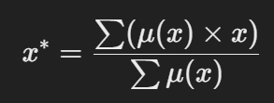**Centroid Method (COG - Center of Gravity):**
2. **Mean of Maximum (MOM):** Finds the **average of maximum membership values**.
3. **Weighted Average Method:** Assigns weights to different values and computes the average.

**Example Application:** In a fuzzy control system for **an air conditioner**, defuzzification translates the fuzzy temperature setting into a specific fan speed.

**UNIT - 4**

**Genetic Algorithm (GA)**

Genetic Algorithms are **powerful optimization techniques** that mimic **natural selection**. By continuously evolving and improving solutions, **GAs help find near-optimal answers** where traditional algorithms fail.

Genetic Algorithms (GAs) are **optimization techniques** inspired by the process of **natural evolution**. They are widely used in solving **complex problems** including **AI, machine learning, robotics, finance, and healthcare** to solve complex real-world problems.

**Working Principle of Genetic Algorithm**

Genetic Algorithms follow the principle of **"survival of the fittest"**, where the best solutions evolve over generations.

**Basic Steps in Genetic Algorithm Execution**

1. **Initialization:**
   * Create a **population of candidate solutions** (chromosomes).
   * Each chromosome represents a **potential solution** to the problem.
2. **Fitness Evaluation:**
   * Compute the **fitness score** of each chromosome.
   * The fitness function determines how **"good"** a solution is.
3. **Selection (Reproduction):**
   * Select the **fittest individuals** for reproduction.
   * Methods: **Roulette Wheel Selection, Tournament Selection, Rank Selection.**
4. **Crossover (Recombination):**
   * Combine genetic material from **two parents** to create offspring.
   * Increases **diversity** in the population.
5. **Mutation:**
   * Introduce **small random changes** in chromosomes.
   * Helps prevent premature convergence to a **local optimum**.
6. **New Generation Formation:**
   * Replace the **old population** with the **new population** of offspring.
   * Repeat the process **until a termination condition is met** (e.g., max generations).

**Genetic Algorithm Operators**

Genetic Algorithms use **three main operators** to evolve solutions:

**Reproduction (Selection)**

* Selects the **best individuals** to pass their genes to the next generation.
* **Selection Methods:**
  1. **Roulette Wheel Selection:** Probability of selection is based on fitness proportion.
  2. **Tournament Selection:** Randomly pick a few individuals and select the best.
  3. **Rank Selection:** Rank individuals and select based on rank probability.
* **Example:**
  1. If **five individuals** have fitness scores: **10, 20, 50, 80, 100**, higher fitness individuals have a better chance of selection.

**Crossover (Recombination)**

* **Combines genetic information** from **two parents** to create offspring.
* **Types of Crossover:**
  1. **Single-Point Crossover:** Swap genes at a single crossover point.
  2. **Two-Point Crossover:** Swap genes at two points for more variation.
  3. **Uniform Crossover:** Randomly mix genes from both parents.
* **Example:**
  1. **Parent 1:** 110011
  2. **Parent 2:** 101101
  3. **After Crossover (One-Point at 3rd bit):**
     + **Child 1:** 110101
     + **Child 2:** 101011
* **Application:** Used in **genetic programming, neural networks, and AI-driven design optimization**.

**Mutation**

* Introduces **random changes** in genes to maintain diversity.
* **Types of Mutation:**
  1. **Bit Flip Mutation:** Randomly flip a bit (0 → 1 or 1 → 0).
  2. **Swap Mutation:** Swap two genes in the chromosome.
  3. **Gaussian Mutation:** Apply small changes based on a Gaussian distribution.
* **Example:**
  1. **Before Mutation:** 110011
  2. **After Mutation (Bit Flip at 2nd bit):** 100011
* **Application:** Used in **feature selection, machine learning, and complex scheduling problems**.

**Advantages of Genetic Algorithms**

* **Global Optimization:** Finds optimal solutions where other techniques get stuck in local minima.
* **Robustness:** Works well even with **incomplete or noisy data**.
* **Parallel Processing:** Can handle **multiple solutions simultaneously**.
* **No Need for Derivatives:** Unlike gradient-based methods, GA works on **any function**.

**Real-World Applications of Genetic Algorithms**

**1. Machine Learning & AI**

* **Feature Selection:** Optimizes feature sets for better model accuracy.
* **Neural Network Training:** Helps find the best **weights and architecture**.

**2. Robotics & Control Systems**

* Used in **robot path optimization** and **motion planning**.
* **Example:** Self-learning robots in **autonomous navigation**.

**3. Finance & Stock Market**

* Optimizes **portfolio management** and trading strategies.
* **Example:** Predicting stock price trends using GA-based models.

**4. Bioinformatics & Drug Discovery**

* **Genetic sequencing** and **protein structure prediction**.
* Helps **design new drugs** by simulating molecular evolution.

**5. Scheduling & Optimization**

* Used in **job scheduling, airline crew scheduling, and supply chain optimization**.
* **Example:** Minimizing airline delays by optimizing flight crew assignments.

**Limitations of Genetic Algorithms**

* **Computationally Expensive:** Requires many iterations.
* **Premature Convergence:** May settle on a **local optimum** rather than a **global optimum**.
* **Parameter Sensitivity:** Performance depends on **mutation rate, crossover rate, and selection strategy**.

**Convergence of Genetic Algorithm (GA)**

Convergence in GA refers to the point at which the algorithm **stabilizes** and **produces no significant improvements** in the fitness of solutions over generations.

**Types of Convergence in GA**

1. **Premature Convergence**
   * The algorithm **quickly settles** on a suboptimal solution (local optimum).
   * Caused by **low mutation rates** or **dominant individuals reducing diversity**.
2. **Slow Convergence**
   * GA takes **too many generations** to reach the optimal solution.
   * Often due to **high mutation rates** or **inefficient selection mechanisms**.
3. **Ideal Convergence**
   * The algorithm **gradually finds the global optimum**.
   * Requires **balanced mutation, crossover, and selection rates**.

**Factors Affecting Convergence**

* **Selection Pressure:** Too strong → Premature convergence, too weak → Slow progress.
* **Mutation Rate:** Too low → Less diversity, too high → Random search behavior.
* **Crossover Rate:** Proper recombination enhances genetic diversity.
* **Population Size:** Small → Limited search space, large → Increased computational cost.

**Stopping Criteria for Convergence**

* **Fixed Number of Generations:** Stop after a predefined number of iterations.
* **Fitness Threshold:** Stop when the best solution reaches a **desired fitness value**.
* **No Improvement Condition:** Stop if **no improvement** is seen over several generations.

**Bit-wise Operations in Genetic Algorithm**

Bit-wise operations play a key role in **genetic representation** of solutions and **mutation**.

**Chromosome Representation in GA**

* A solution (chromosome) is encoded as a **bit string (binary representation)**.
* Example: **10110101** represents a chromosome.

**Common Bit-wise Operations in GA**

1. **Bit-wise Crossover**
   * Two parents exchange bits at a crossover point.
   * Example:
     + **Parent 1:** 101011
     + **Parent 2:** 110100
     + **After Crossover:** 101100, 110011
2. **Bit-wise Mutation**
   * Randomly flips a **bit** in the chromosome.
   * Example:
     + **Before Mutation:** 101011
     + **After Mutation (Bit Flip at Position 3):** 100011
3. **Bit-wise Masking**
   * Uses **AND, OR, XOR** operations to **modify genetic material**.
   * Example (AND Operation):
     + **Chromosome 1:** 101011
     + **Mask:** 111000
     + **Result (AND):** 101000

**Role of Bit-wise Operations in GA**

* **Efficient Representation:** Encodes solutions in binary format.
* **Diversity Preservation:** Maintains genetic variation through bit flips.
* **Fast Computation:** Bit-wise operations are computationally efficient.

**Solving Optimization Problems using Genetic Algorithms**

GA is widely used in **solving complex optimization problems** where traditional methods fail.

**Steps to Solve an Optimization Problem using GA**

1. **Define the Problem:**
   * Identify the **objective function** to be optimized (minimized/maximized).
2. **Chromosome Representation:**
   * Encode solutions as **bit strings or real-valued vectors**.
3. **Initialize Population:**
   * Generate an **initial population** randomly or using heuristics.
4. **Evaluate Fitness Function:**
   * Measure how good each solution is.
5. **Selection, Crossover, Mutation:**
   * Apply **genetic operators** to produce new solutions.
6. **Convergence Check:**
   * Stop when **optimal solution** is reached or progress stalls.

**Example: Solving the Traveling Salesman Problem (TSP) with GA**

* **Problem:** Find the shortest route that visits all cities exactly once.
* **Chromosome Representation:** Cities are **encoded as sequences**.
* **Fitness Function:** Minimize **total travel distance**.
* **Operators Used:**
  + **Crossover:** Swap city sequences between parents.
  + **Mutation:** Swap or reverse city order.
* **Result:** GA finds an **approximate shortest path** in a reasonable time.

**Applications of GA in Optimization**

* **Job Scheduling:** Assign tasks efficiently to minimize completion time.
* **Path Planning:** Optimize robot and drone movement.
* **Stock Market Prediction:** Optimize investment strategies.
* **Feature Selection in ML:** Select the best set of input features.

**Multi-Level Optimization in Genetic Algorithm**

Multi-level optimization is used when an optimization problem has **multiple interdependent levels**.

**Definition**

* It involves **two or more levels of optimization**, where solutions at one level **affect** solutions at another.
* GA is used to **solve sub-problems hierarchically**.

**Approaches to Multi-Level Optimization in GA**

1. **Hierarchical Genetic Algorithm (HGA)**
   * Solves **high-level (macro)** problems first, then refines **low-level (micro)** details.
   * Example: Optimizing **car design**, then **engine parameters**.
2. **Cooperative Coevolutionary GA (CCGA)**
   * Breaks problems into **sub-components**, optimizing each separately.
   * Example: Optimizing **neural network layers independently**.
3. **Hybrid Multi-Objective GA**
   * Uses **multiple GAs** to handle **conflicting objectives**.
   * Example: **Minimizing cost** while **maximizing performance** in software design.

**Real-world Applications of Multi-Level GA**

* **Supply Chain Optimization:** Minimizing cost at multiple levels (warehouses, transportation).
* **Biomedical Engineering:** Designing **multi-layered prosthetic limbs**.
* **Network Routing:** Finding **optimal routes** at different hierarchical levels.

**UNIT - 5**

**Multi-Objective Optimization Problem (MOOP)**

Multi-Objective Optimization (MOOP) refers to **optimization problems** that involve multiple, often conflicting objectives that need to be optimized simultaneously.

**Unlike single-objective optimization**, where a single best solution exists, MOOP aims to find a **set of trade-off solutions** that balance the competing objectives.

Multi-objective optimization is **essential in real-world applications** where trade-offs between competing objectives must be balanced.

**Examples of MOOPs:**

* **Engineering Design:** Minimizing weight while maximizing strength in structural design.
* **Finance:** Maximizing portfolio return while minimizing risk.
* **Supply Chain Management:** Reducing costs while improving delivery speed and customer satisfaction.
* **Machine Learning:** Maximizing accuracy while minimizing computational cost.

**Key Concepts in MOOP**

**a) Pareto Optimality**

* A solution is called **Pareto optimal** if no other solution can improve one objective without worsening another.
* The set of all Pareto-optimal solutions is called the **Pareto front** or **Pareto frontier**.

**b) Dominance Principle**

* A solution **X dominates Y** if X is better in at least one objective and not worse in others.
* **Non-dominated solutions** form the Pareto front.

**c) Trade-off Solutions**

* **Unlike single-objective optimization**, there is no "**one best solution**" in MOOP.
* Instead, a decision-maker selects a solution based on the **best compromise among objectives**.

**Challenges in Solving MOOPs**

**a) High Computational Complexity**

* Searching for Pareto-optimal solutions is computationally expensive, especially in large-scale problems with many objectives.
* The **complexity increases exponentially** with the number of objectives.

**b) Conflicting Objectives**

* Objectives may be **mutually conflicting**, meaning improving one objective leads to the deterioration of another.
* Example: In automobile design, increasing safety may increase weight, reducing fuel efficiency.

**c) Diversity of Solutions**

* Obtaining a diverse set of Pareto-optimal solutions is challenging.
* Many optimization algorithms tend to **converge prematurely** to a subset of solutions.

**d) Decision-Making Complexity**

* Unlike single-objective problems, selecting a final solution requires an additional decision-making process.
* Decision-makers must use **preference-based methods** or **interactive decision-making** to choose the most suitable solution.

**e) Scalability Issues**

* As the number of objectives increases, **visualizing** and **analyzing** Pareto-optimal solutions becomes difficult.
* **High-dimensional Pareto fronts** are harder to interpret and use in decision-making.

**f) Lack of Well-Defined Metrics**

* Evaluating the performance of a multi-objective optimization algorithm is **non-trivial** because there is no single best solution.
* Various metrics like **hypervolume**, **spread**, and **convergence indicators** are used, but they do not always provide a clear picture.

**Techniques for Solving MOOPs**

**a) Weighting Method**

* Converts the MOOP into a **single-objective problem** by assigning weights to different objectives.
* Example: **Minimize (w1 × Cost + w2 × Time)**.
* **Limitation:** Requires predefined weights, which may not always be easy to determine.

**b) Pareto-Based Methods**

* Generate a **Pareto front** and allow decision-makers to choose from a set of optimal solutions.
* Example algorithms: **NSGA-II (Non-dominated Sorting Genetic Algorithm), SPEA2 (Strength Pareto Evolutionary Algorithm)**.

**c) Goal Programming**

* Assigns **desired target values** for each objective and minimizes deviations from these targets.
* Useful when decision-makers have a clear preference for specific objectives.

**d) Evolutionary and Metaheuristic Algorithms**

* **Genetic Algorithms (GA), Particle Swarm Optimization (PSO), Differential Evolution (DE)** are commonly used to solve MOOPs.
* These methods **evolve populations** of solutions over generations to approximate the Pareto front.

**Multi-Objective Evolutionary Algorithm (MOEA)**

Multi-Objective Evolutionary Algorithms (MOEAs) are optimization techniques based on **evolutionary principles** (such as natural selection and genetic variation) used to solve **Multi-Objective Optimization Problems (MOOPs)**. These algorithms are designed to find **a set of optimal trade-off solutions** rather than a single best solution.

**Key Features of MOEAs:**

* **Simultaneous optimization of multiple objectives** instead of aggregating them into one.
* **Use of populations** to maintain diversity and explore multiple solutions.
* **Stochastic (randomized) search** based on natural evolutionary processes.
* **Pareto-based selection** to identify trade-off solutions.

**Working Principles of MOEA**

MOEAs operate using **evolutionary operators** such as selection, crossover and mutation. The general workflow is:

1. **Initialization:** Generate a random population of solutions.
2. **Evaluation:** Compute fitness values based on multiple objectives.
3. **Selection:** Choose better-performing individuals based on Pareto dominance.
4. **Crossover & Mutation:** Introduce genetic variation to explore new solutions.
5. **Ranking & Sorting:** Organize solutions into Pareto fronts (better trade-offs rank higher).
6. **Replacement & Iteration:** Continue evolving until convergence criteria are met.

**Popular MOEAs**

**a) Non-Dominated Sorting Genetic Algorithm II (NSGA-II)**

* One of the most widely used MOEAs.
* Uses **fast non-dominated sorting** and **crowding distance** to maintain solution diversity.
* Provides an efficient way to approximate **Pareto-optimal solutions**.

**b) Strength Pareto Evolutionary Algorithm 2 (SPEA2)**

* Maintains an **external archive** of Pareto-optimal solutions.
* Uses a strength-based fitness assignment strategy.
* Efficiently **preserves diversity** and prevents premature convergence.

**c) Multi-Objective Particle Swarm Optimization (MOPSO)**

* Based on **Particle Swarm Optimization (PSO)**, which mimics swarm behavior.
* Uses **global and local best solutions** to guide search.
* Works well for **continuous multi-objective problems**.

**d) Pareto Archived Evolution Strategy (PAES)**

* Uses a **single-parent evolution strategy** with a local search approach.
* Stores Pareto-optimal solutions in an archive for better diversity.
* Less computationally expensive than NSGA-II and SPEA2.

**Challenges and Recent Advances in MOEA**

**Challenges:**

* **Scalability:** Handling **many-objective problems (more than 3 objectives)** is complex.
* **Convergence vs Diversity:** Ensuring both a wide-spread Pareto front and accurate solutions.
* **High Computation Cost:** Evolutionary algorithms can be computationally expensive.
* **Decision-Making Complexity:** Selecting a final solution from the Pareto front can be difficult.

**Recent Trends in MOEA:**

* **Hybrid MOEAs:** Combining MOEAs with **machine learning techniques** to enhance performance.
* **Parallel MOEAs:** Utilizing **GPU computing and distributed computing** for faster optimization.
* **Many-Objective Evolutionary Algorithms (MaOEAs):** Designed for problems with **more than 3 objectives**.
* **Deep Learning Integration:** MOEAs are being integrated with **neural networks** to improve solution quality.

**Recent Trends in Various Classifiers**

**(a) Introduction to Classifiers**

Classifiers are machine learning models used to **categorize data into predefined labels** based on input features. The recent advancements in classifiers focus on improving **accuracy, interpretability and efficiency**.

**(b) Recent Trends in Classifiers**

**1. Deep Learning-Based Classifiers**

* **Convolutional Neural Networks (CNNs):** Used for **image classification** (e.g., face recognition, medical diagnosis).
* **Recurrent Neural Networks (RNNs) & LSTMs:** Used in **text classification** (e.g., sentiment analysis, chatbot responses).
* **Transformers (BERT, GPT):** Advanced **NLP-based classifiers** for text understanding and classification.

**2. Ensemble Learning Classifiers**

* **Boosting Algorithms (XGBoost, AdaBoost, LightGBM):** Enhance weak classifiers by combining multiple models.
* **Bagging Methods (Random Forest):** Improve stability by training multiple decision trees on different subsets of data.
* **Stacking:** Uses multiple models and combines their predictions for better accuracy.

**3. Explainable AI (XAI) Classifiers**

* **Interpretable Machine Learning (LIME, SHAP):** Improves model transparency.
* **Rule-Based Learning (Decision Trees, Rule-Induction Models):** Helps in explainable decision-making.

**4. Quantum Machine Learning Classifiers**

* **Quantum Neural Networks (QNNs):** Leveraging quantum computing for faster classification tasks.
* **Quantum Support Vector Machines (QSVMs):** An improvement over traditional SVMs using quantum states.

**5. Hybrid Classifiers**

* **Neuro-Symbolic AI:** Combining deep learning with logical reasoning for improved decision-making.
* **Fuzzy Logic + Neural Networks:** Used for **uncertain and imprecise data** (e.g., medical diagnosis).

**Swarm Optimization Algorithms**

Swarm optimization algorithms are inspired by the **collective intelligence** of natural systems such as **ants, bees and bird flocks**.

These algorithms are used in optimization problems where **multiple agents** (particles, ants or bees) **work together to explore and find optimal solutions**.

**Ant Colony Optimization (ACO)**

Ant Colony Optimization (ACO) is a **nature-inspired optimization technique** based on the **foraging behavior of ants**. In nature, ants use **pheromone trails** to mark paths leading to food sources, and over time, the best paths get reinforced while weaker paths fade. This behavior is modeled in ACO to solve **graph-based optimization problems** such as the **Traveling Salesman Problem (TSP)** and **network routing**.

**Working Principle of ACO**

1. **Initialization**: Ants are placed randomly on different nodes of the problem space (e.g., cities in TSP).
2. **Pheromone Deposition**: Ants explore paths and deposit **pheromones** on edges as they move.
3. **Path Selection (Exploration and Exploitation)**:
   * **Higher pheromone concentration = Higher probability of choosing that path**.
   * Ants use a **probabilistic transition rule** to select the next step.
4. **Evaporation**: Pheromone trails evaporate over time to prevent stagnation in local optima.
5. **Updating Best Solution**: The best path found is reinforced by increasing pheromone concentration.
6. **Convergence**: Over multiple iterations, ants converge to the **optimal or near-optimal solution**.

**Applications of ACO**

* **Network Routing:** Efficient routing of data packets in communication networks.
* **Traveling Salesman Problem (TSP):** Finding the shortest possible route among multiple cities.
* **Logistics & Supply Chain Optimization:** Optimizing warehouse-to-customer delivery routes.
* **Scheduling Problems:** Job-shop scheduling and project scheduling.

**Bee Colony Optimization (BCO)**

Bee Colony Optimization (BCO) is inspired by the **foraging behavior of honeybees**.

Bees communicate using **waggle dance**, which helps them find the best nectar sources.

This cooperative behavior is simulated in BCO for **optimization problems**.

**Working Principle of BCO**

1. **Initialization**: A population of bees is randomly distributed in the search space.
2. **Bee Phases**:
   * **Employed Bees:** Search for food sources (candidate solutions) and evaluate their quality.
   * **Onlooker Bees:** Select the best food sources based on information shared by employed bees.
   * **Scout Bees:** Randomly explore new areas when a food source is exhausted (prevents stagnation).
3. **Updating Best Solutions**: The best food sources (solutions) are reinforced.
4. **Convergence**: Over multiple iterations, the algorithm converges to an optimal solution.

**Applications of BCO**

* **Job Scheduling:** Optimizing job assignments and task scheduling.
* **Clustering and Image Segmentation:** Used in **data mining and medical imaging**.
* **Wireless Sensor Networks (WSN):** Optimizing energy-efficient routing.
* **Financial Portfolio Optimization:** Selecting the best stocks based on return-risk trade-offs.

**Particle Swarm Optimization (PSO).**

Particle Swarm Optimization (PSO) is an **optimization technique inspired by the**

**collective movement of bird flocks and fish schools**.

It is used to solve **continuous and discrete optimization problems**.

**Working Principle of PSO**

1. **Initialization**: A swarm of particles (candidate solutions) is randomly placed in the solution space.
2. **Velocity and Position Update**:
   * Each particle **adjusts its velocity** based on:
     + **Personal Best Position (Pbest):** Best solution the particle has found so far.
     + **Global Best Position (Gbest):** Best solution found by the entire swarm.
   * Velocity and position update formulas:

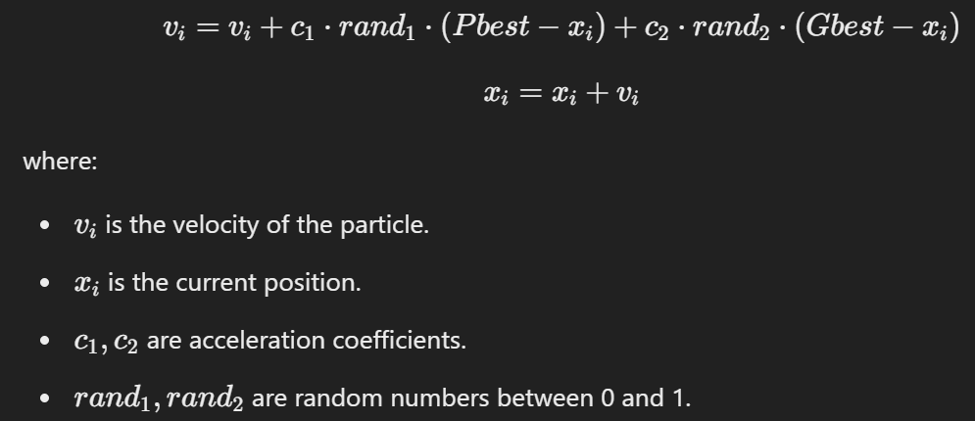

1. **Convergence**: The swarm gradually moves toward the optimal solution.

**Variants of PSO**

* **Inertia Weight PSO:** Adjusts the **influence of past velocities** to balance exploration and exploitation.
* **Constriction Factor PSO:** Ensures **convergence stability** by controlling velocity updates.
* **Adaptive PSO:** Adjusts **parameters dynamically** to improve efficiency.

**Applications of PSO**

* **Function Optimization:** Used in engineering design and parameter tuning.
* **Neural Network Training:** Optimizing weights in **Artificial Neural Networks**.
* **Image Processing:** Feature selection and image classification.
* **Control Systems:** Applied in robotics for **path planning** and **motion control**.

**Swarm Intelligence**

Swarm Intelligence (SI) refers to the **emergent behavior of decentralized, self-organizing systems**. The key principles include:

* **Simple rules leading to complex global behavior.**
* **No central control**—intelligent behavior emerges from **local interactions**.
* **Self-organization and adaptability** to changing environments.

**Key Characteristics of Swarm Intelligence**

1. **Decentralization:** No single leader—control is distributed.
2. **Positive Feedback:** Encourages successful solutions to grow.
3. **Negative Feedback:** Removes weaker solutions to prevent stagnation.
4. **Self-Organization:** Adaptive behavior emerges naturally.
5. **Diversity Maintenance:** Maintains solution variety to avoid premature convergence.

**Applications of Swarm Intelligence**

* **Optimization Problems:** Used in **robotics, machine learning, and scheduling problems**.
* **Traffic Management:** Intelligent traffic light control using swarm intelligence.
* **Finance & Stock Market Analysis:** Predicting stock trends and portfolio optimization.
* **Internet of Things (IoT):** Efficient energy management in smart grids.

**Optimization Techniques for Swarm Intelligence**

* Ant Colony Optimization (ACO)
* Bee Colony Optimization (BCO)
* Particle Swarm Optimization (PSO)
* Artificial Fish Swarm Algorithm (AFSA)
* Firefly Algorithm (FA)
* Bat Algorithm (BA)
* Dragonfly Algorithm (DA)
* Grey Wolf Optimizer (GWO)
* Cuckoo Search Algorithm (CSA)
* Glowworm Swarm Optimization (GSO)

**Comparison of ACO, BCO and PSO**

| **Feature** | **Ant Colony Optimization (ACO)** | **Bee Colony Optimization (BCO)** | **Particle Swarm Optimization (PSO)** |
| --- | --- | --- | --- |
| **Inspiration** | Ant foraging behavior | Honeybee foraging and communication | Bird flocking and fish schooling |
| **Search Mechanism** | Pheromone trails | Employed, Onlooker, and Scout Bees | Particle velocity and position |
| **Solution Space** | Discrete | Discrete and continuous | Continuous |
| **Communication** | Indirect (via pheromone) | Direct (via bee dances) | Direct (via global and personal best) |
| **Exploration & Exploitation** | Balances exploration with pheromone evaporation | Adaptive search based on food source quality | Adaptive velocity adjustments |
| **Common Applications** | TSP, Network Routing, Scheduling | Clustering, Image Processing, WSN | Function Optimization, Neural Networks, Robotics |

**Conclusion**

Swarm Optimization Algorithms **leverage collective intelligence** to find optimal solutions efficiently.

* **Ant Colony Optimization (ACO)** is ideal for **graph-based problems** like TSP and network routing.
* **Bee Colony Optimization (BCO)** is **adaptive and robust** for clustering and job scheduling.
* **Particle Swarm Optimization (PSO)** is widely used for **continuous optimization problems** and **machine learning applications**.